Supplementary Material



**Figure S1. Fluorescence based time-kill curves.** Logarithmized fluorescence values are plotted against the time (h). Ten different dilutions of each antimicrobial, positive control (Inf) and negative control (conc. 0) were tested on eight WHO reference panel strains. Start concentrations were calibrated to approximately 107 CFU/ml which corresponds to a log fluorescence of 6. From 0-3 hours negative controls without antimicrobial resulted in decreased bacterial numbers, at 6 hours all samples show increased fluorescence.

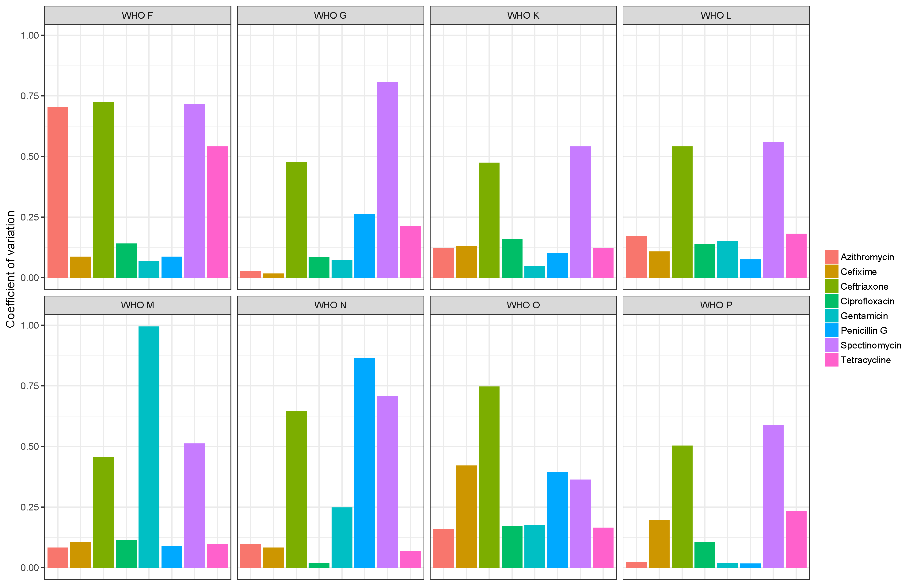

**Figure S2. Intra assay coefficient of variation.** To test the reproducibility of the resazurin MIC assay eight antimicrobials were tested on eight WHO reference strains (n=64). The mean and standard deviation of three independent experiments was calculated. The coefficient of variation (ratio of standard deviation over the mean) was calculated for sample. Barplots are shown for each sample. The mean of the coefficient of variation (intra assay CV) is 0.28.

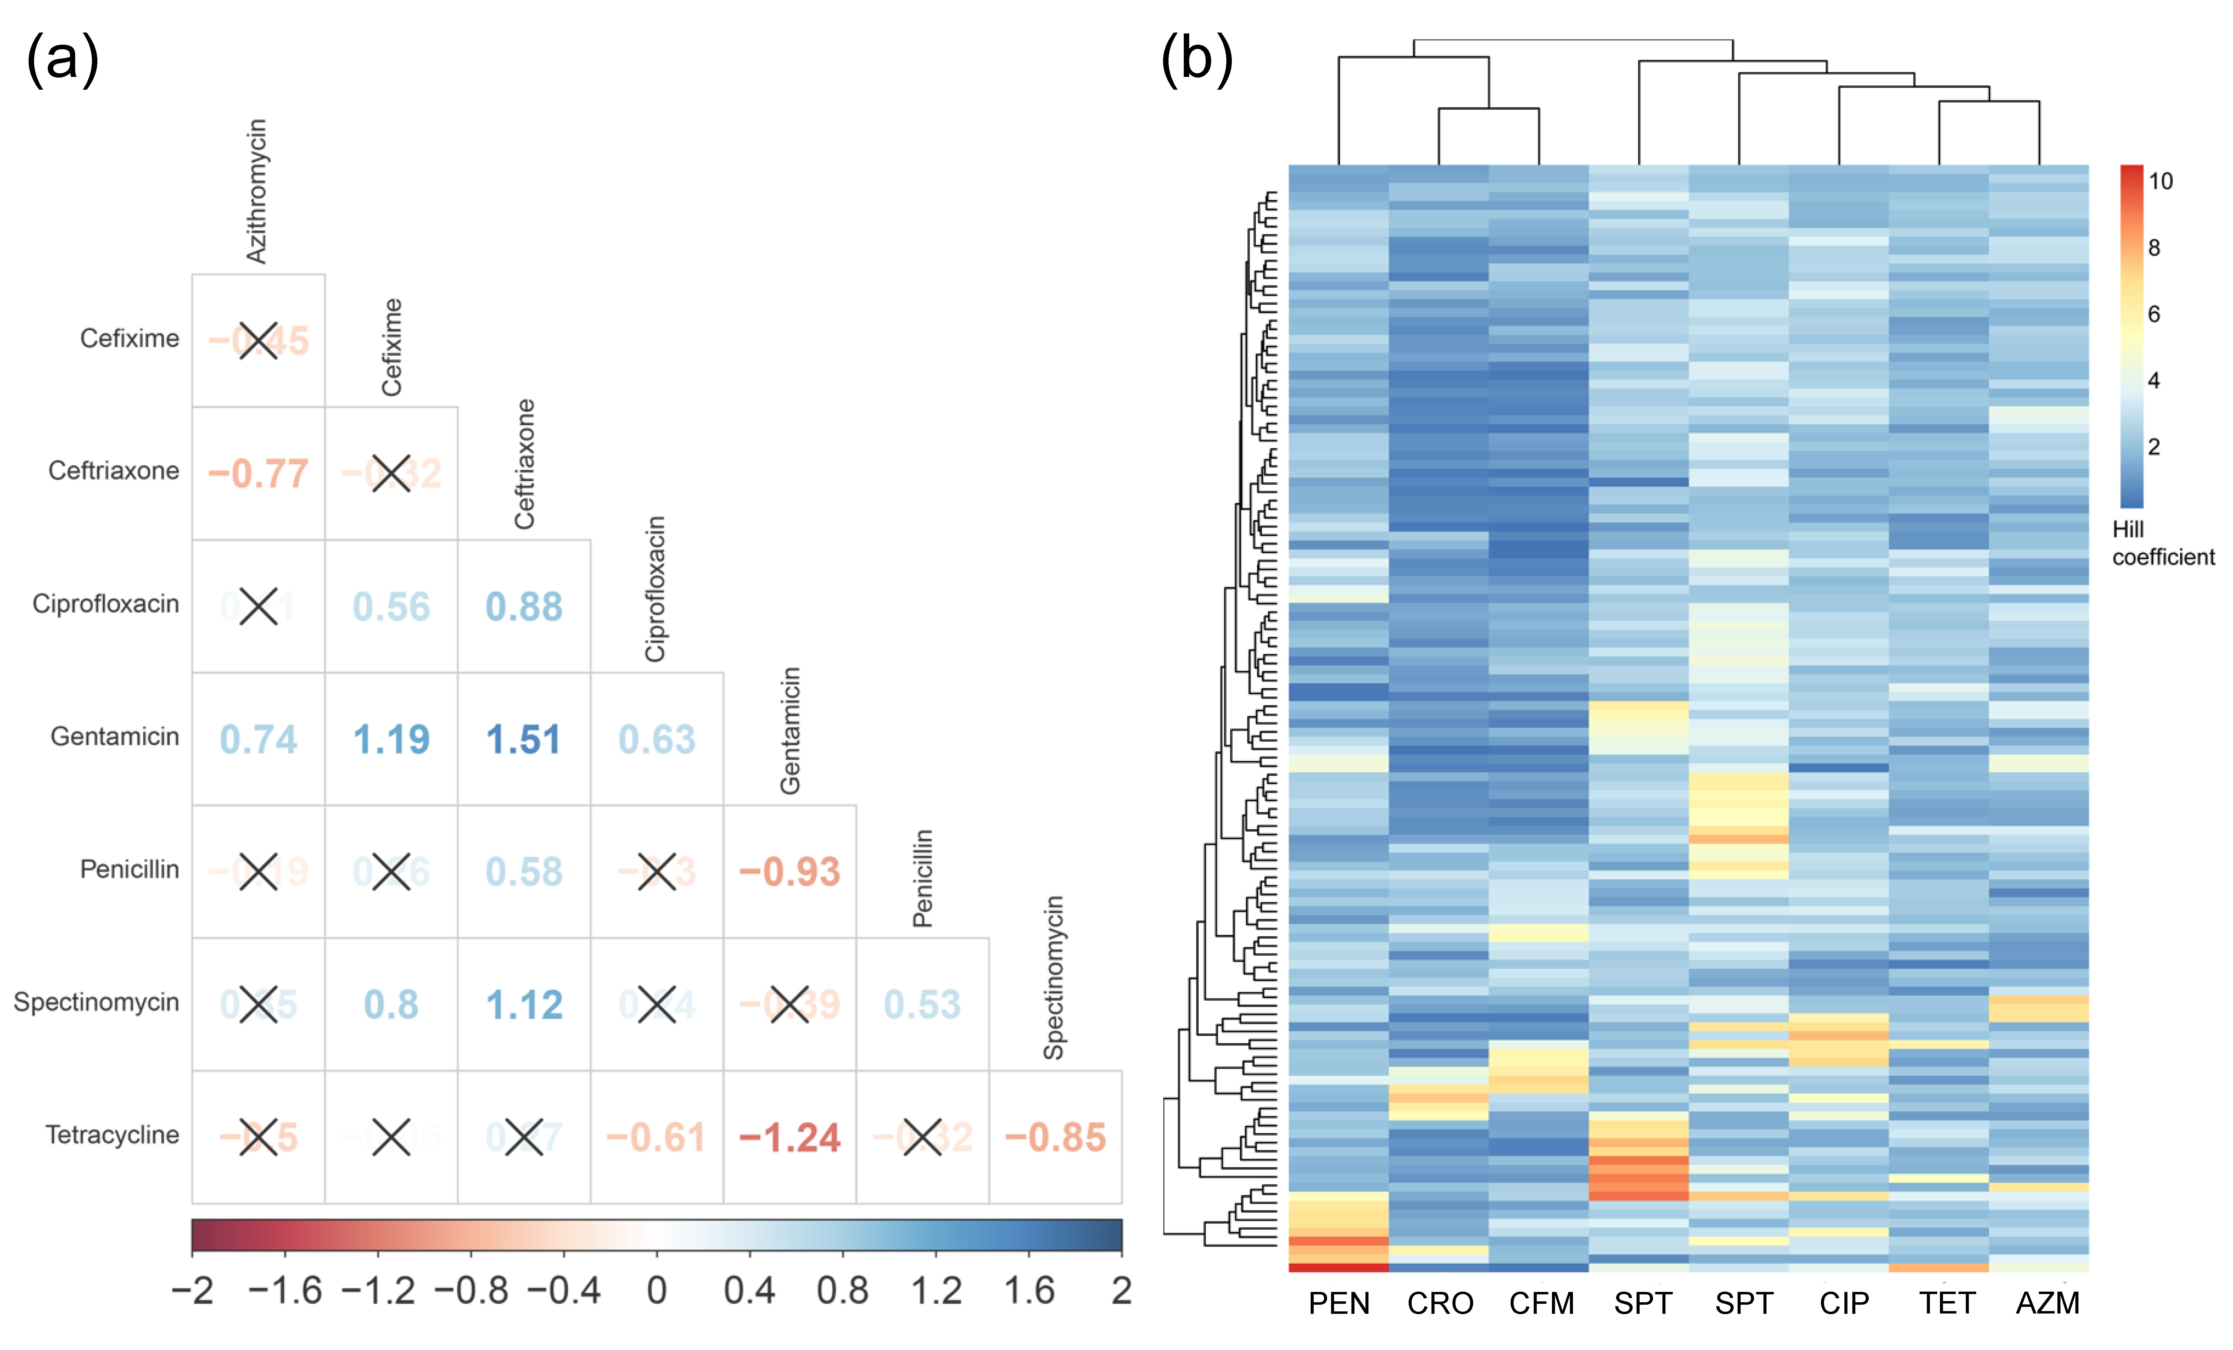

**Figure S3. Difference of Hill coefficients.** (A) The difference between the mean of 124 Hill coefficients (124 clinical strains examined) is shown for each antimicrobial combination. High values are shown in an increasingly intense blue colour gradient and low values in red. A pairwise t-test was performed and non-significant differences (p value > 0.05) marked with a black cross. (B) Hierarchical clustering of Hill coefficients. Rows represent Hill coefficients for different strains (N=124) and columns antimicrobials. The β-lactams penicillin G, ceftriaxone and cefixime are more similar to each other than to the other antimicrobials.

p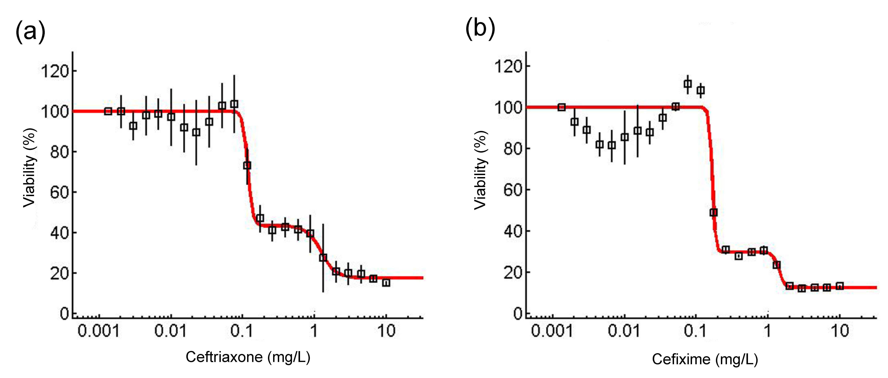

**Figure S3. Biphasic dose response curves.** The viability (%) was plotted against 24 different antimicrobial concentrations. Mean and standard error of three independent experiments are shown. (a) Ceftriaxone in Strain 11 (validation data). A biphasic model (red curve) fits the model better (bic=563) than a monophasic model (bic=794).1 The first EC50is at 0.12 mg/L and the second at 1.21 mg/L (Etest MIC=0.125 mg/L). (b) Cefixime in Strain 11 (validation data). A biphasic model (red curve) fits the model better (bic=850) than a monophasic model (bic=8574). The first EC50is at 0.16 mg/L and the second at 1.39 mg/L (Etest MIC=0.25 mg/L).

References

1. Di Veroli GY, Fornari C, Goldlust I, *et al.* An automated fitting procedure and software for dose-response curves with multiphasic features. *Sci Rep* 2015; **5**: 14701.